Batch: D2 Roll No.: 16010221038

Experiment / assignment / tutorial No.____6___

Grade: AA / AB / BB / BC / CC / CD /DD

Signature of the Staff In-charge with date

**Title– Moment of Inertia of Flywheel Objective**

To determine the moment of inertia of a flywheel.

**Theory**

The flywheel consists of a heavy circular disc/massive wheel fitted with a strong axle projecting on either side.The axle is mounted on ball bearings on two fixed supports. There is a small peg on the axle. One end of a cord is loosely looped around the peg and its other end carries the weight-hanger.

Let "m" be the mass of the weight hanger and hanging rings (weight assembly).When the mass

"m" descends through a height "h", the loss in potential energy is



The resulting gain of kinetic energy in the rotating flywheel assembly (flywheel and axle) is



Where

I -moment of inertia of the flywheel assembly ω-angular velocity at the instant the weight assembly touches the ground.

The gain of kinetic energy in the descending weight assembly is,



Where v is the velocity at the instant the weight assembly touches the ground.

The work done in overcoming the friction of the bearings supporting the flywheel assembly is



Where

n - number of times the cord is wrapped around the axle

Wf - work done to overcome the frictional torque in rotating the flywheel assembly completely once

Therefore from the law of conservation of energy we get



On substituting the values we get



Now the kinetic energy of the flywheel assembly is expended in rotating N times against the same frictional torque. Therefore

and



If r is the radius of the axle, then velocity v of the weight assembly is related to r by the equation



Substituting the values of v and Wf we get:



Now solving the above equation for I



Where, I = Moment of inertia of the flywheel assembly

N = Number of rotation of the flywheel before it stopped m = mass of the rings n = Number of windings of the string on the axle g = Acceleration due to gravity of the environment. h = Height of the weight assembly from the ground.

r = Radius of the axle.

Now we begin to count the number of rotations, N until the flywheel stops and also note the duration of time t for N rotation. Therefore we can calculate the average angular velocity in radians per second.



Since we are assuming that the torsional friction Wf is constant over time and angular velocity is simply twice the average angular velocity



**Setup Diagram:**

v

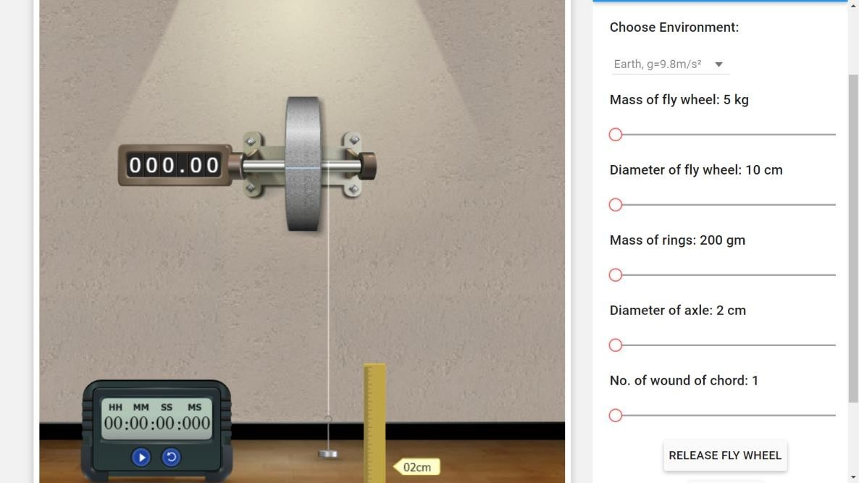

**PROCEDURE:**

1. Choose any desired environment by clicking on the ‘combo box’.
2. Adjust the sliders to have suitable dimensions for flywheel arrangement.
3. Click on ‘Release fly wheel’ to start the experiment.
4. No of revolutions (N) of the flywheel, after the loop slips off from peg is indicated on the side of axle.
5. The time taken by flywheel to come to rest is noted from stop watch.
6. Repeat the experiment for different values of variables.

**OBSERVATION TABLE:**

|  |  |  |  |  |  |  |  |  |  |
| --- | --- | --- | --- | --- | --- | --- | --- | --- | --- |
| **S**  **r.**  **N**  **o** | **Mass suspended**  **(m) x 10-3kg** | **Height above the**  **ground (h) x 10-2 m** | **Radius of axle**  **(r)**  **X 10-2 m** | **Number of revolutions** | | **Time for N revolu tions**  **(t) sec** | **Mean angular velocity**  **(ω) rad/sec** | **MI of flywheel**  **(Expt) Kg-m2** | **MI of flywheel**  **(Therotical**  **)**  **Kg-m2** |
| n | N |
| **1** | **200** | **2cm** | **1** | **1** | **22.94** | **42.223** | **6.83** | **0.0063** | **0.0016** |
| **2** | **400** | **2cm** | **1** | **1** | **47.26** | **60.605** | **9.80** | **0.0063** | **0.0016** |
| **3** | **600** | **2cm** | **1** | **1** | **59.28** | **67.755** | **10.99** | **0.0063** | **0.0018** |
| **4** | **200** | **10cm** | **1** | **5** | **100.27** | **89.728** | **14.04** | **0.0063** | **0.0019** |
| **5** | **200** | **20cm** | **1** | **10** | **194.09** | **124.97** | **19.52** | **0.0063** | **0.0019** |
| **6** | **200** | **2cm** | **1.5** | **1** | **33.94** | **51.156** | **8.34** | **0.0063** | **0.0010** |
| **7** | **200** | **2cm** | **2** | **1** | **47.26** | **60.715** | **9.78** | **0.0063** | **0.0007** |

**CALCULATION:**

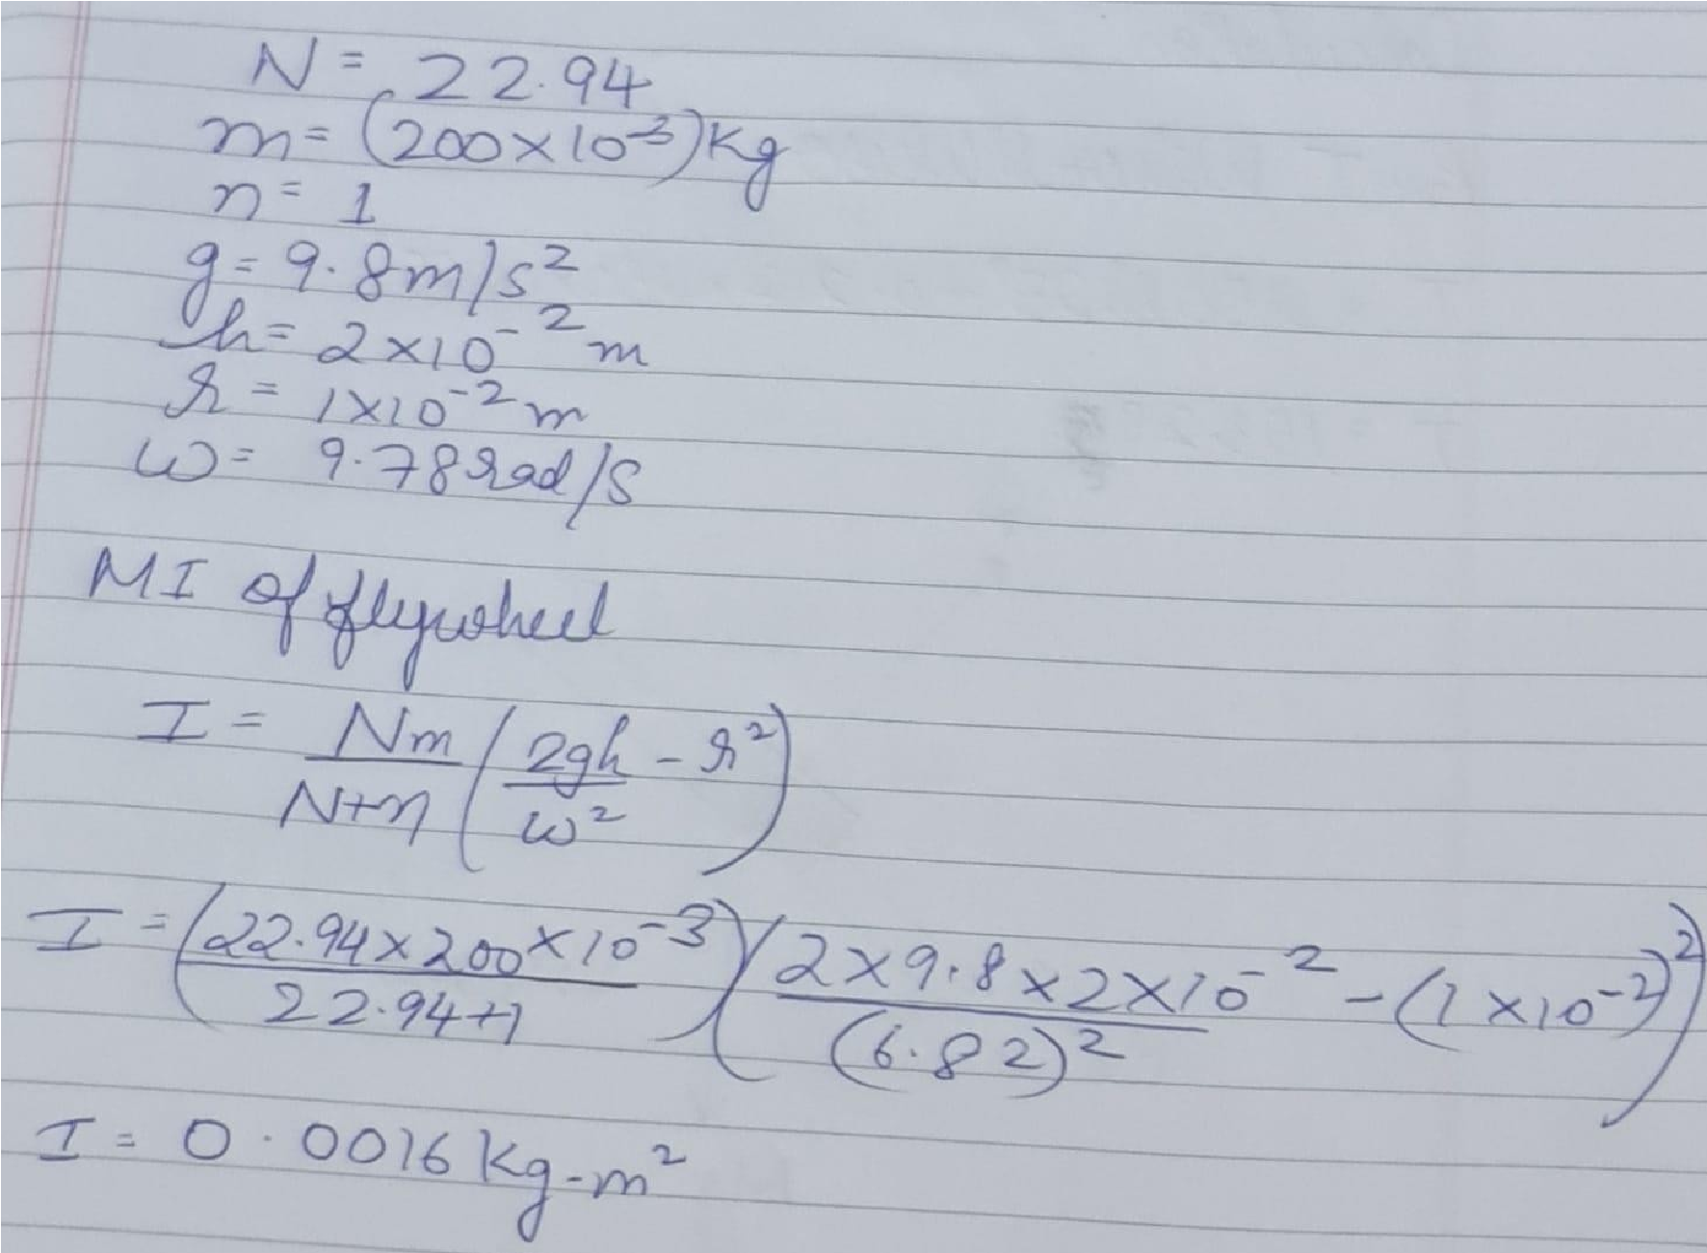

**Conclusion:**

1.With increase in ’m’ , ‘N’ is increasing and time to come to rest is also increasing.

1. With increase in ‘n’ , ‘N’ and time both are increasing.
2. With increase in diameter of axle ‘N’ is increasing.
3. For the same weight and diameter of flying wheel , experimental value is same
4. The difference between theoretical values and experimental values is le

# K J Somaiya College of Engineering, Mumbai-77

**(Somaiya Vidyavihar University)**

## Self-evaluation





**Department of Mechanical Engineering**

July-Dec-2020

# K J Somaiya College of Engineering, Mumbai-77

**(Somaiya Vidyavihar University)**

## Feedback Signature of faculty in-charge

**Department of Mechanical Engineering**

July-Dec-2020